**User Manual For**

**Admin:**

1. Admin can have a login form for entering to the admin panel. Where they can put their email address, and password.

If the credentials do not match, an error message will be displayed.

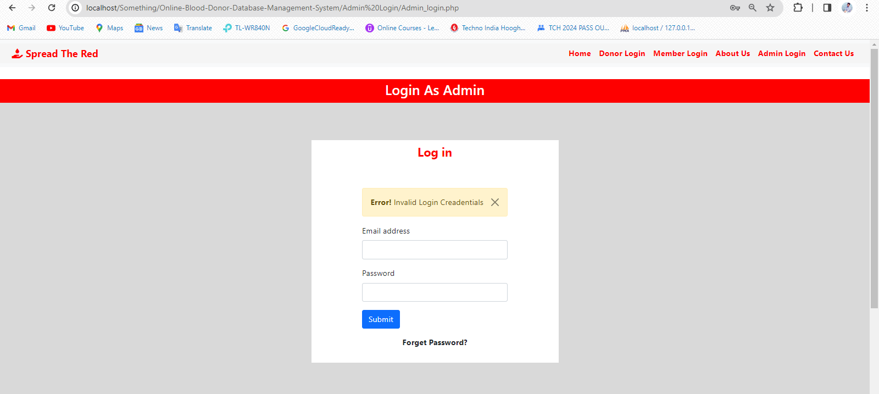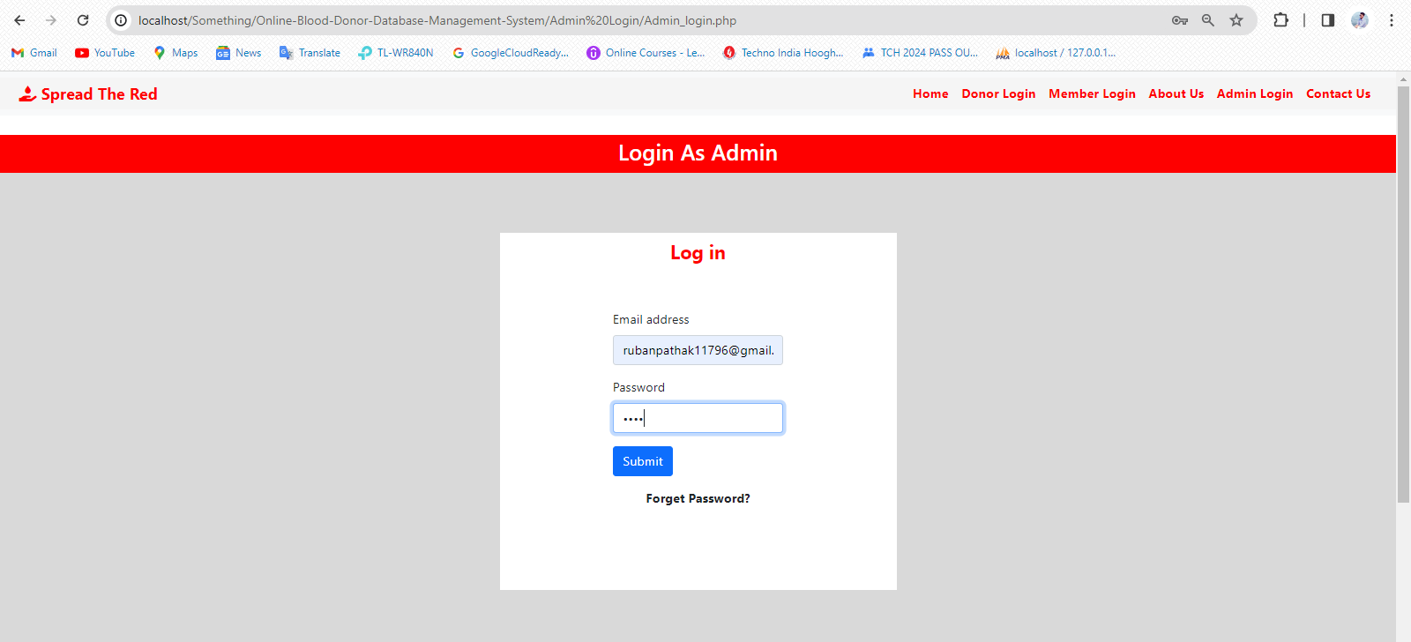

1. 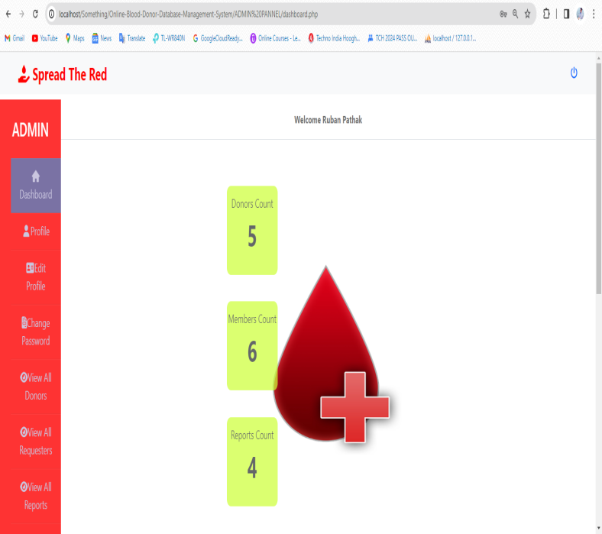Otherwise the login process is complete and the donor will be redirected to the Dashboard.

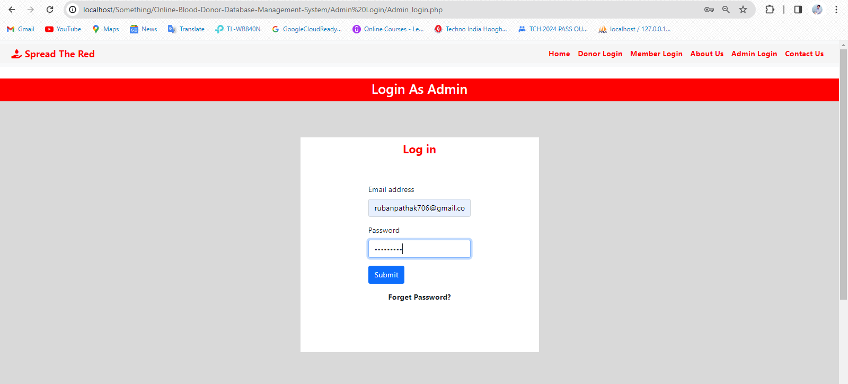

1. In the view all reports section all the reports can be seen and verified by Admin and the admin can sent warning or block or unblock the user.

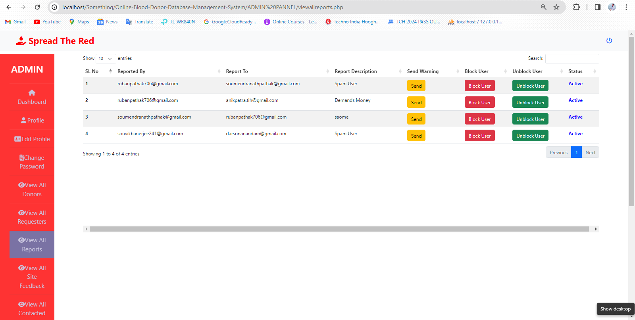

TO SENT A WARNING TO A USER CLICK ON THE SEND BUTTON

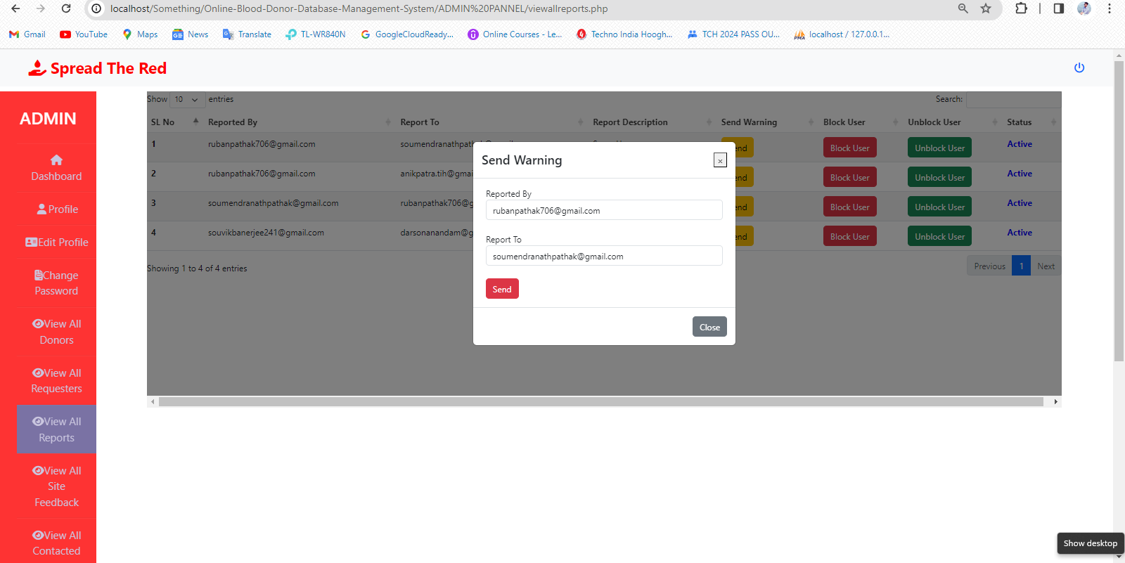

NEXT CLICK ON THIS BUTTON AND WAIT FOR SOME SECONDS

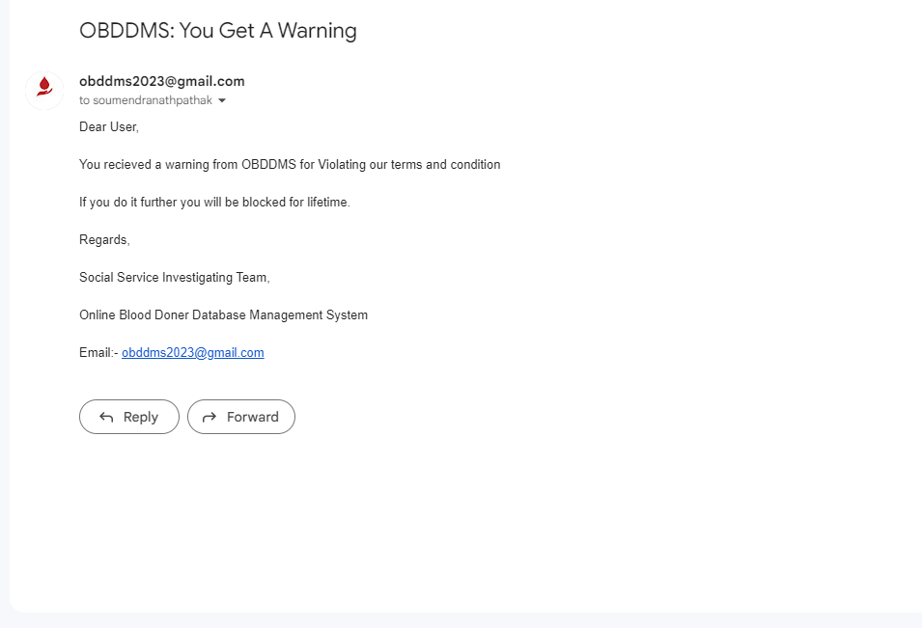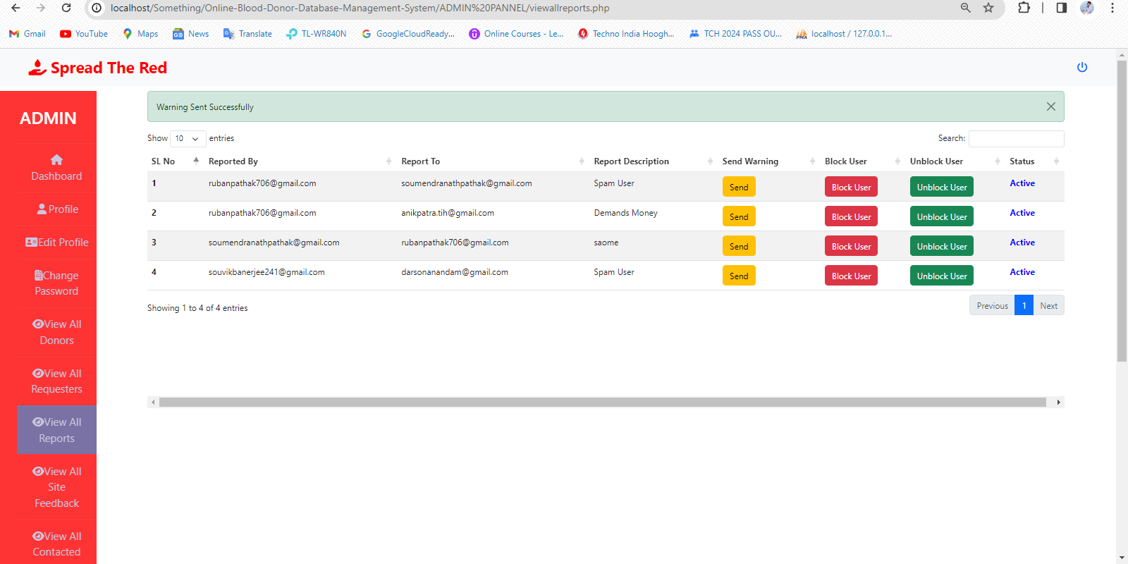



TO BLOCK AN USER CLICK ON THE BLOCK BUTTON

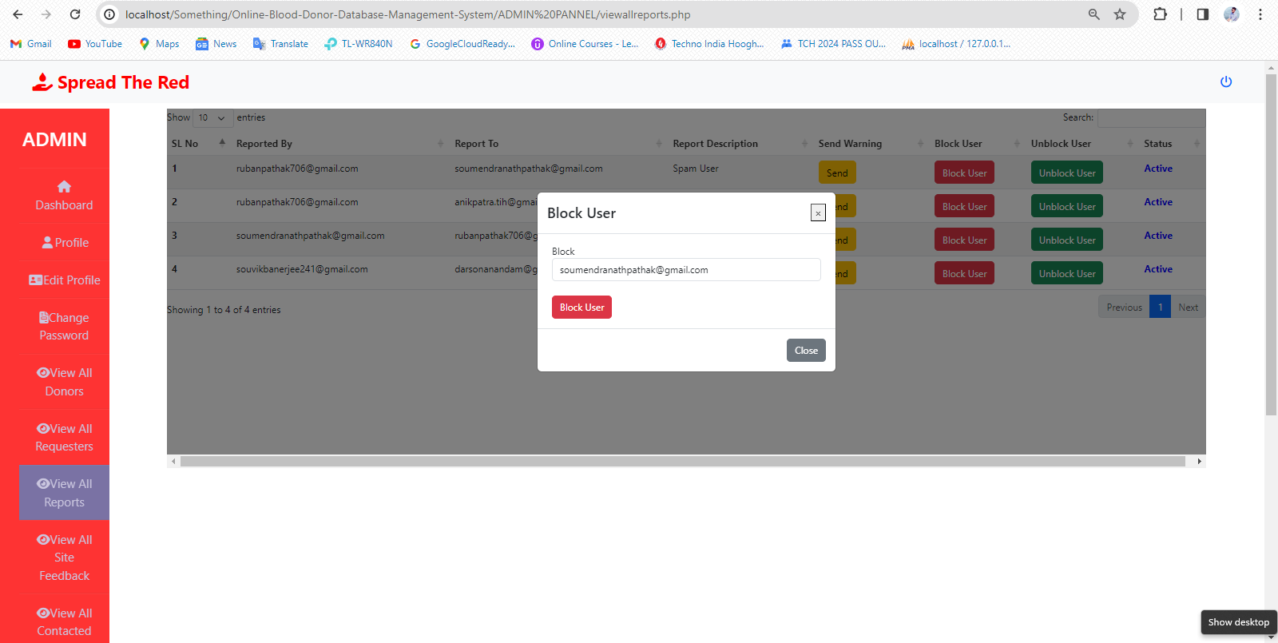

NEXT CLICK ON THIS

BUTTON AND WAIT FOR

SOME SECONDS

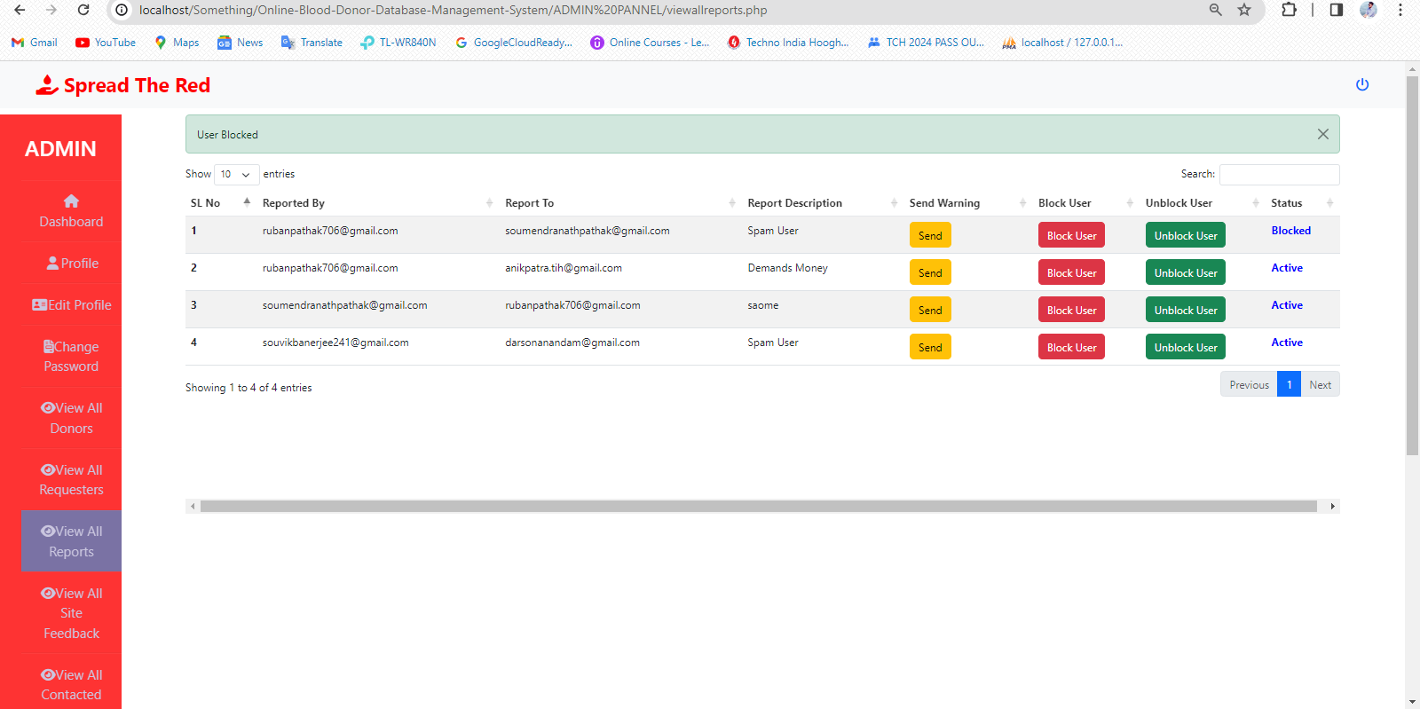

USER CAN BE BLOCKED AND STATUS CAN BE CHANGED TO BLOCKED

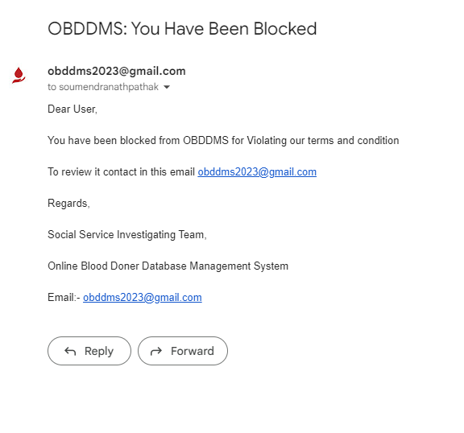

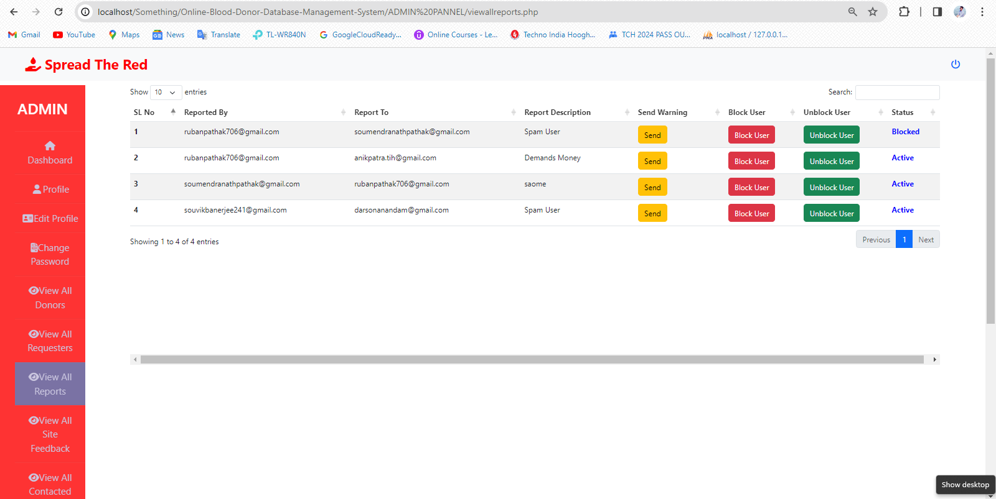

TO UNBLOCK AN USER CLICK ON THE UNBLOCK BUTTON

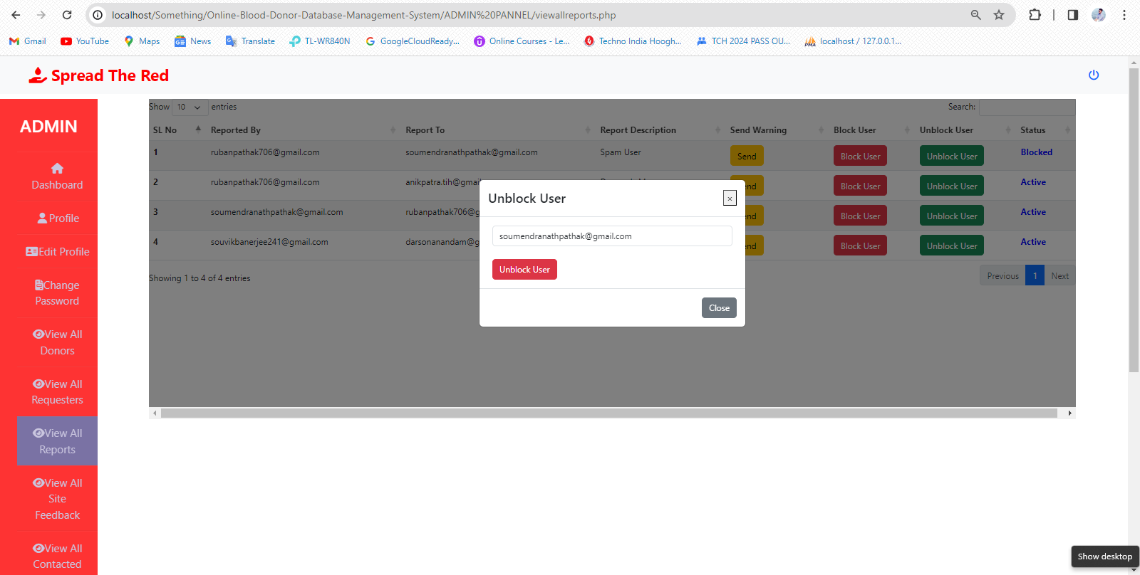

NEXT CLICK IN THIS BUTTON TO UNBLOCK AND WAIT FOR FEW SECONDS

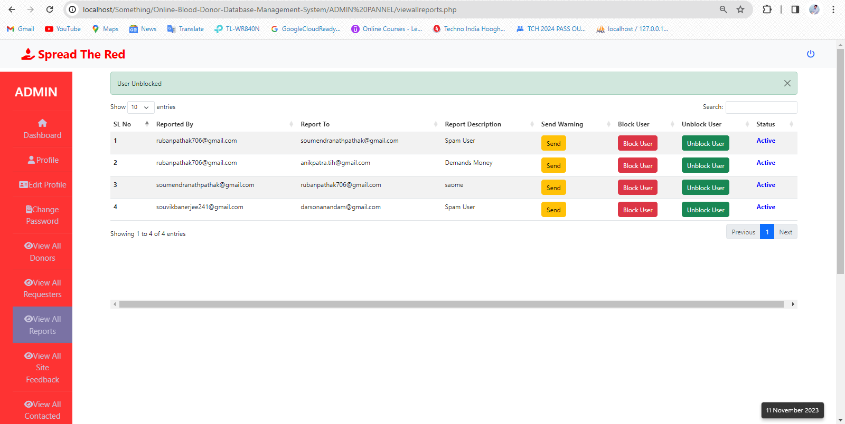

USER CAN BE UNBLOCKED AND THE STATUS CAN BE CHANGED

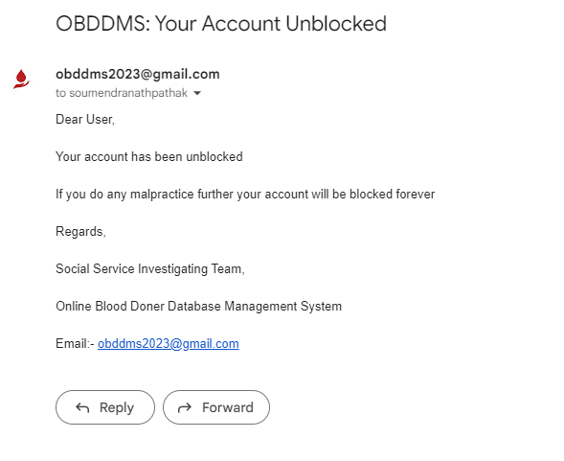

1. 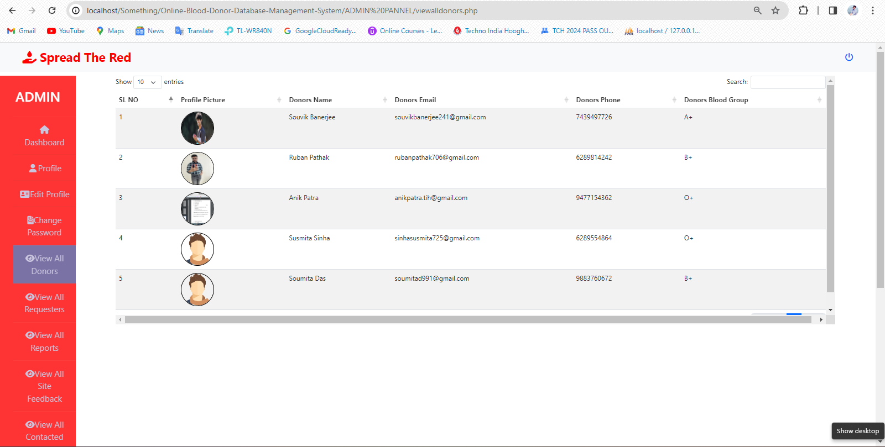Now, in the VIEW ALL DONORS section Admin can see all the donors .

1. In the VIEW ALL MEMBERS section Admin can see all the blood requesters.

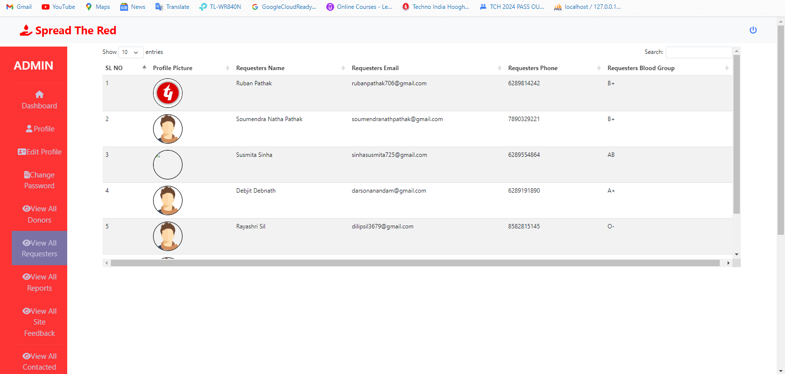

1. In the VIEW ALL SITE FEEDBACK section Admin can see all the feedbacks.



1. In the VIEW ALL CONTACTED PEOPLE section Admin can see all the donors and requesters can contacted with each other and the timings.

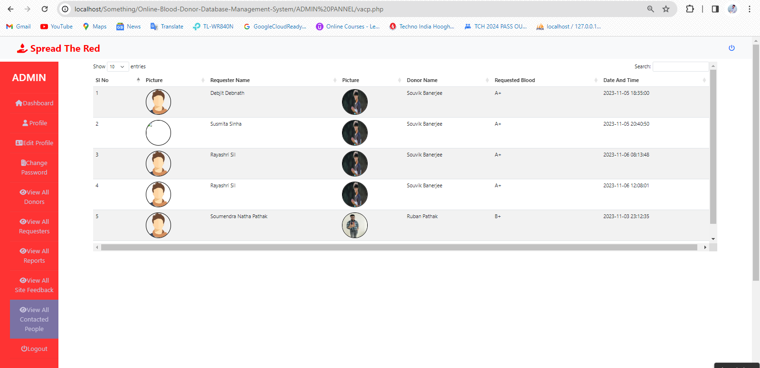

1. Admin can view their profile through the ‘Profile’ option.

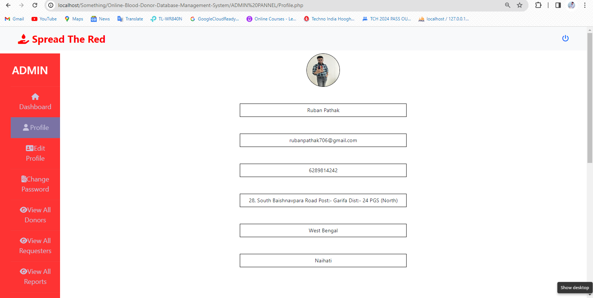

1. 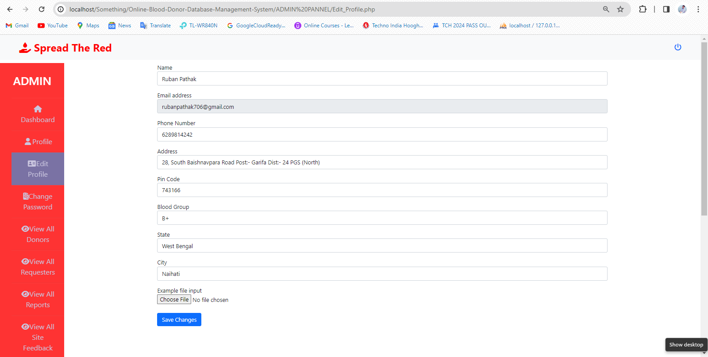Admin also will be able to edit their basic account details via ‘Edit Profile’ option.
2. Any time admin can change their password through the ‘Change Password’ option.

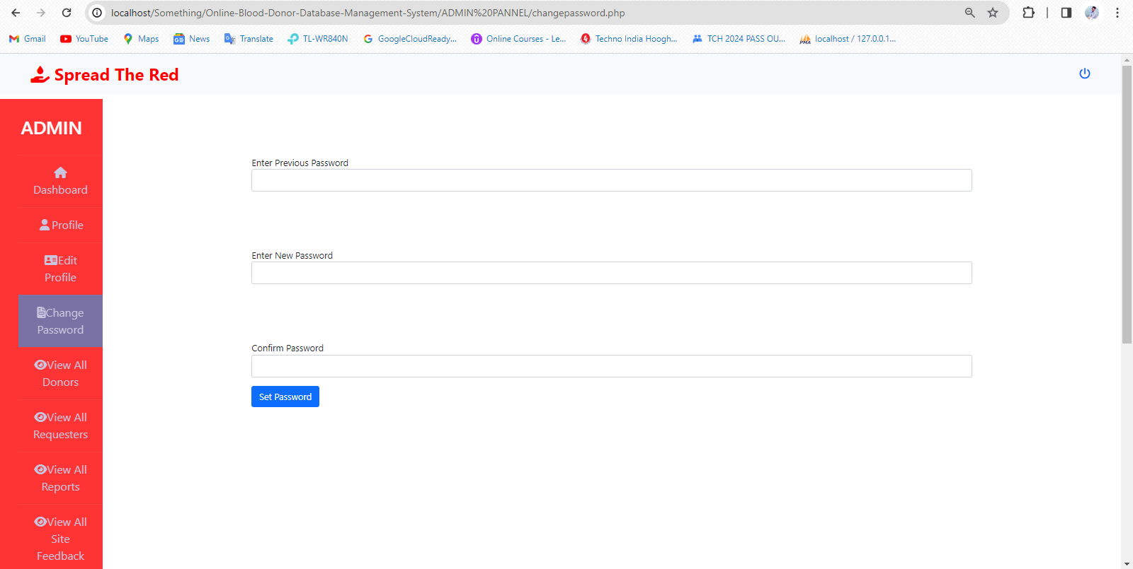

1. Admin can also change there password from forget password section.

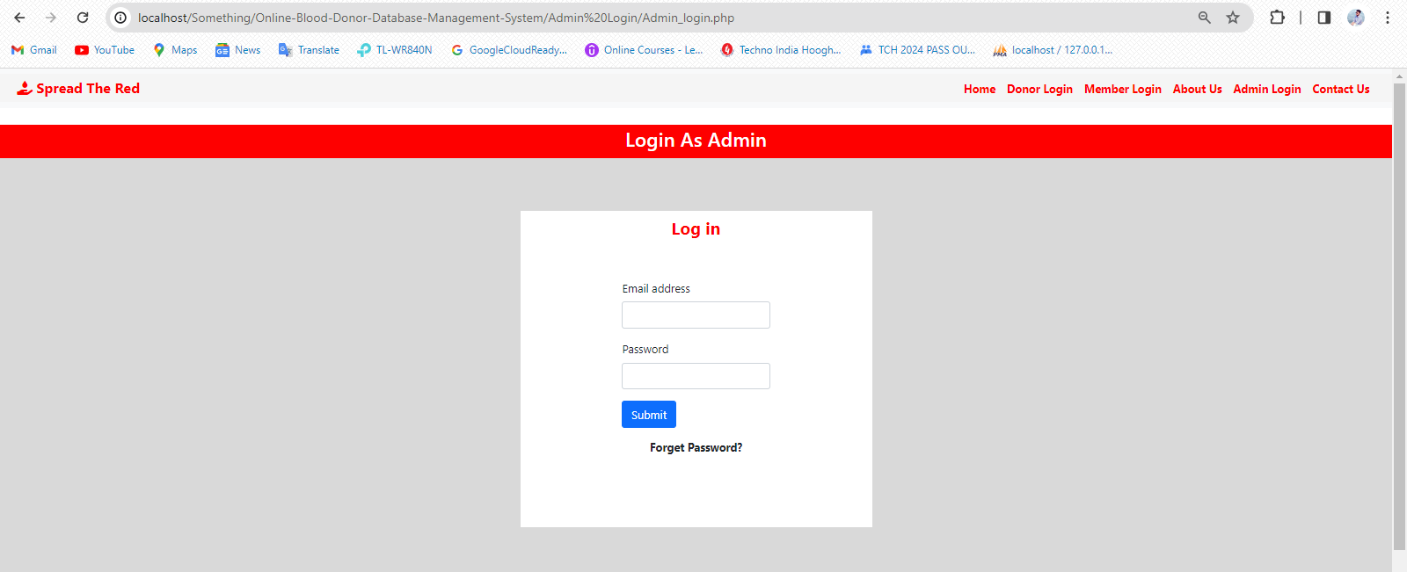

FIRST CLICK HERE

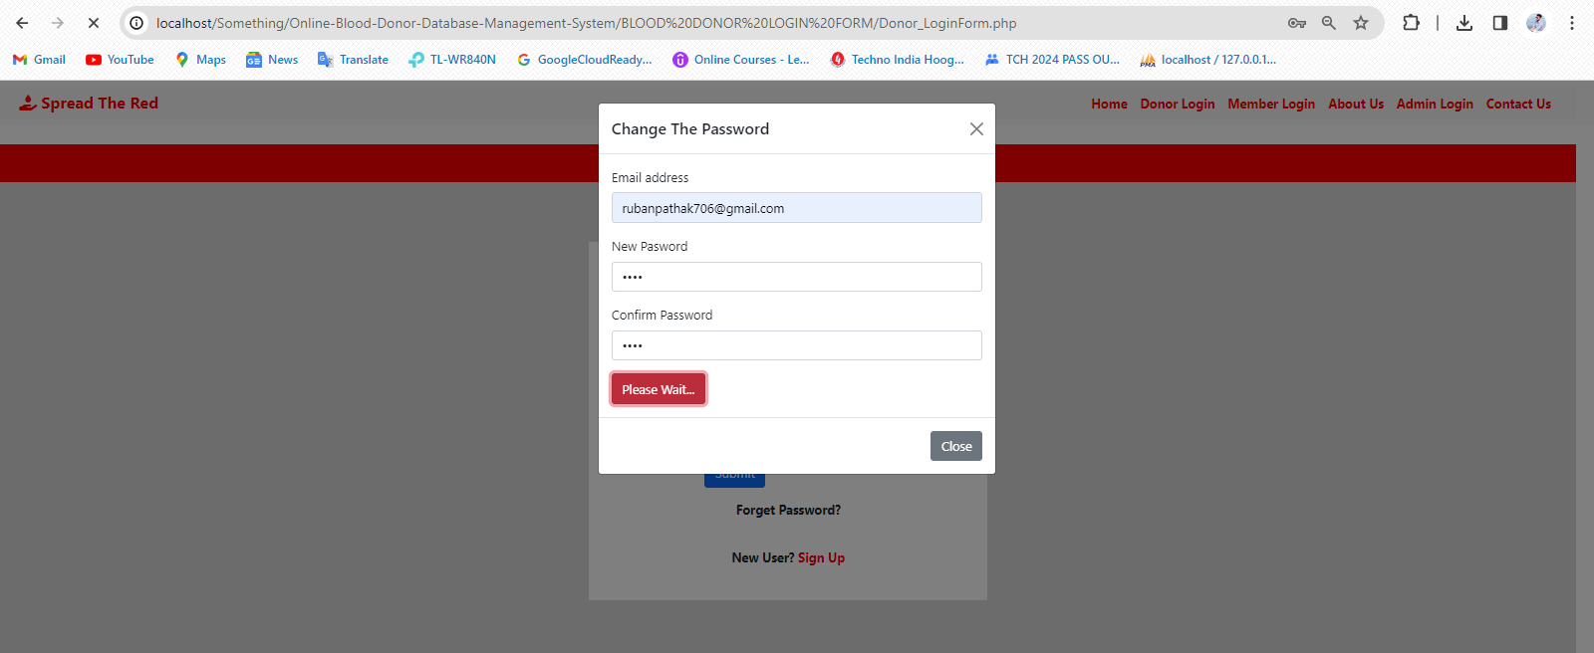

AFTER FILLING UP THE FORM CLICK HERE

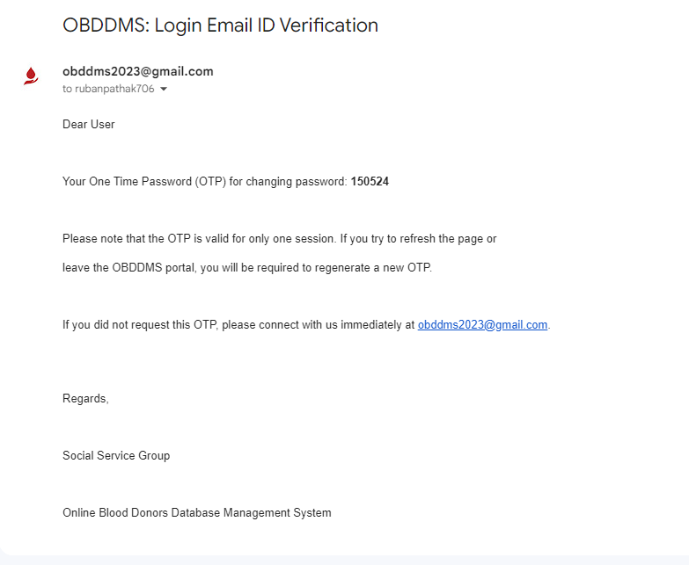

COPY THIS OTP

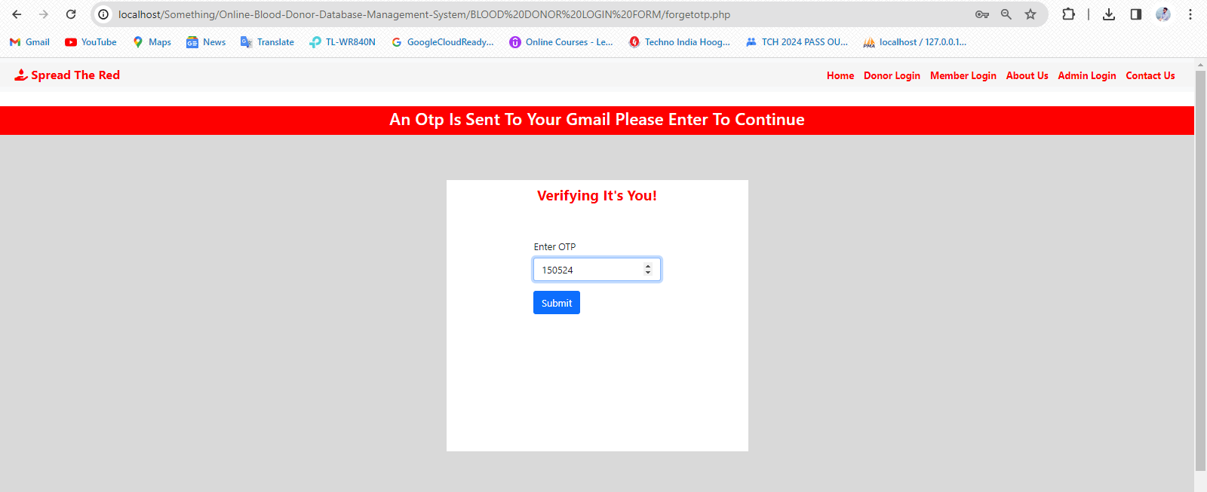

PASTE THE OTP AND SUBMIT THE OTP TO CHANGE YOUR PASSWORD